Government funds $2.95M for world’s first reusable hypersonic UAV project

Aerospace engineering business Hypersonix Launch Systems (“Hypersonix”) together with the University of Southern Queensland, LSM Advanced Composites (“LSM”) and New South Wales-based Romar Engineering (“Romar”) have been awarded a $2.95M Cooperative Research Centres Projects (“CRC-P”) grant from the Federal Government.

The project, titled ‘DART CMP Airframe – a reusable hypersonic platform’, is a UAV (Unmanned Aerial Vehicle) that can travel at hypersonic speeds up to Mach 12 (twelve times the speed of sound). It is powered by the SPARTAN hydrogen fuelled scramjet engine.

Scramjets take oxygen from the atmosphere, a fact that reduces weight by 60% compared to rockets. The development of new high temperature composite materials in this project will enable DART CMP to be reusable. With zero CO₂ emissions thanks to the green hydrogen fuel, Hypersonix is leading a new era of ‘Green access to space’.
The project will deliver a new sovereign manufacturing capability for high temperature oxide-oxide ceramic matrix composites.

The deliverables include a complete UAV airframe including composite aeroshell and aerodynamic control surfaces, flight avionics, and hydrogen fuel system.
Hypersonix Managing Director David Waterhouse said DART CMP is the composite version of the DART AE due for launch in 2023.
“AE stands for Additive Engineering and is the fully 3D printed version out of high temperature alloys that are already available in Australia,” Mr Waterhouse said.
“The type of high temperature composites we require for DART CMP are currently not available here, therefore there is an urgent need to develop these materials in Australia.
“We are thankful that the government acknowledged this gap and responded with accepting our application. We can’t wait to have these materials ready in mid 2025.”
Hypersonix CTO Michael Smart added “And we are proud to support three PhD students with this project as well, we need more experts in this developing industry.”
The University of Southern Queensland’s Institute for Advanced Engineering and Space Sciences Executive Director Professor Peter Schubel said the CRC-P success was an exciting step for its ongoing collaboration with Hypersonix Launch Systems.

“The University of Southern Queensland is applying its research expertise in the field of hypersonics and future materials to help realise an innovative mission," Professor Schubel said.

“Our role in the project will be to develop and test the prototype ultra-high temperature composite material needed.
“Our expertise in liquid moulding technologies, automated fibre placement, pultrusion and filament winding capabilities with exotic materials allows us to develop revolutionary structures.
“As an industry-focused research and technology organisation, we are committed to delivering real-world, large-scale solutions for our clients, utilising our extensive laboratories and manufacturing equipment.”
Additive Manufacturing/3D Printing will be used where possible and will be covered by Romar Engineering with Steve Milanoski, ex-SpaceX, leading the steadily growing additive manufacturing team.

The DART CMP UAV will undergo hardware in the loop bench testing as part of flight readiness.
This is not the first Federal government grant awarded to Hypersonix. With the successful completion of an ‘Accelerating Commercialisation program’ (“ACA grant”) by 31st March on time and on budget, the team is excited to prepare for project DART CMP starting in July 2022.

Romar Engineering is also no stranger to government grants having been awarded a Modern Manufacturing Initiative (“MMI”) Space grant in 2021 for $5.85m for the development of its fluid and motion control business.

Romar has developed significant capability in materials characterisation for metal 3D printing and has established manufacturing expertise using L-DED and L-PBF technologies. The Romar Advanced Manufacturing team offers total engineering solutions from early-stage design and prototyping through to serial manufacture of space rated components.

“We are very excited to be working with Hypersonix, USQ and LSM on the development of the DART CMP. The project represents a significant leap forward in technology for the fast-growing Australian space industry.” said, Romar CEO, Alan Lipman.

LSM Advanced Composites Managing Director Liam Mahoney adds: “LSM Advanced Composites is proud to be a participant in this unique project for a hypersonic UAV, which will be revolutionary in the development of high temperature ceramic composite components.”

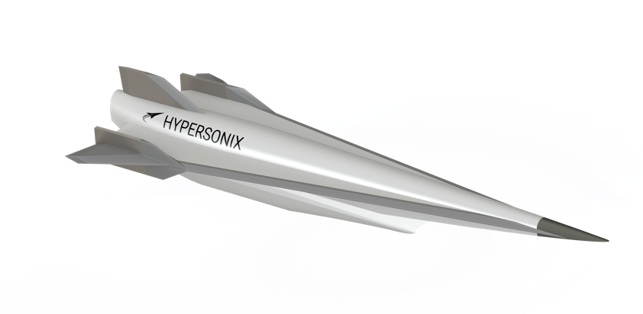
ABOUT HYPERSONIX
Hypersonix Launch Systems is an Australian engineering, design and build company specializing in scramjet engines and hypersonic technology. Hypersonix is developing several hypersonic vehicles that fly at hypersonic speeds between Mach 5 and Mach 12 with zero CO₂ emissions, only water vapor, and have applications in both satellite launch and high-speed aviation.
For more information, please watch the company video at https://vimeo.com/538520388
and go to www.hypersonix.com.au

Media contact:
Nina Patz, Email: Nina.Patz@hypersonix.com.au, Phone: 0400 679 499
Rhianwen Whitney, Email: rhianwen.whitney@usq.edu.au, Phone: 0427 428 380

